Volante VAT Change - Pricing Stage 1
To be completed on the 31st March 2022.
- To change prices on menu items, select ‘Menu Setup’ from the Volante BackOffice main menu.
- Select the 1st Menu Item that will have a price change applied. Select ‘Edit’ & then select the ‘Price History’ tab.
- Select ‘Add’ and set ‘Effective Date’ as 1-Apr-2022 & set the price to what it will be as of the 1st April 2022

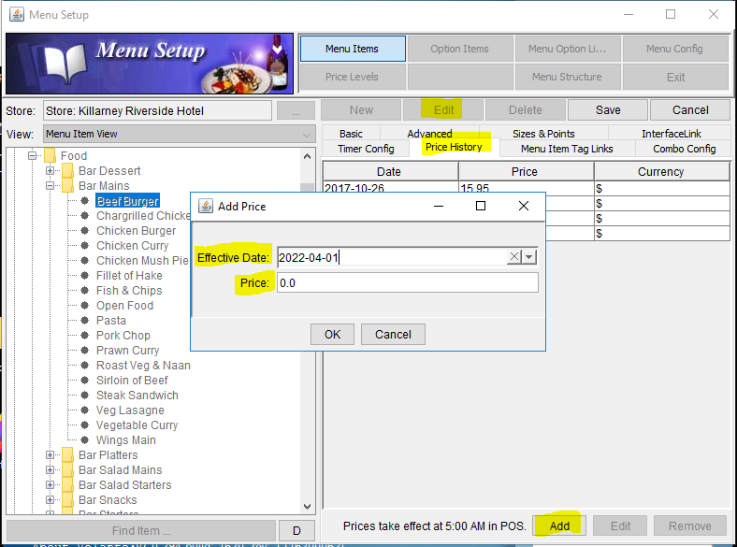

- This will need to be done for all menu items individually.
- Check if using Price Levels, in the Volante BackOffice main menu, select ‘Hardware’ & then ‘Terminal Setup’. Check all terminals to see if any price levels are ticked.
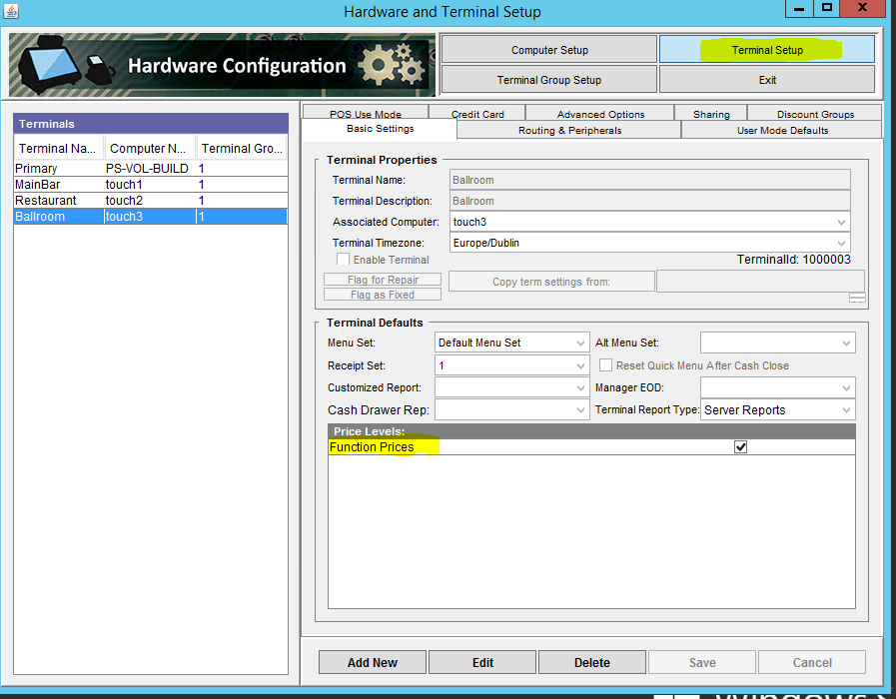
If using Price Levels continue to Step 6, if not go to Step 12
- In ‘Menu Setup’ select ‘Price Levels’ & click ‘New’
- Create a new Price Level (e.g. Restaurant Prices 2021)
- Make the items available in the Price Level by dragging the ‘Division’ folder from the left hand side to the box on the right hand side.
- Expand the ‘Division’ folder in the box & navigate to the 1st menu item to be adjusted.
- Highlight the item & in the ‘Price Change’ box add the price that the item will be as of 1st October 2021, click on ‘Apply Changes’ & click ‘Yes’. Use the = symbol before the price to set the required price. e.g =15.00
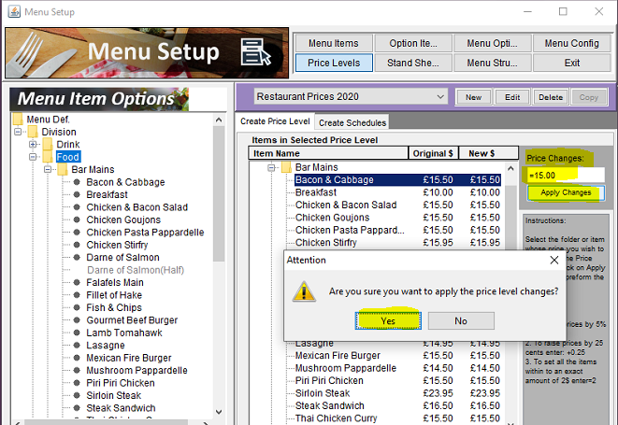

- This will need to be done for all menu items individually.
- Check the Price Level Schedule for the Price Level(s) that is being replaced & replicate this on the new Price Level(s)
- Exit to the main menu in Volante BackOffice
- Select ‘Data Synch’
- Select ‘Send updates to Terminals’ & choose ‘Menu Setup’ & click OK
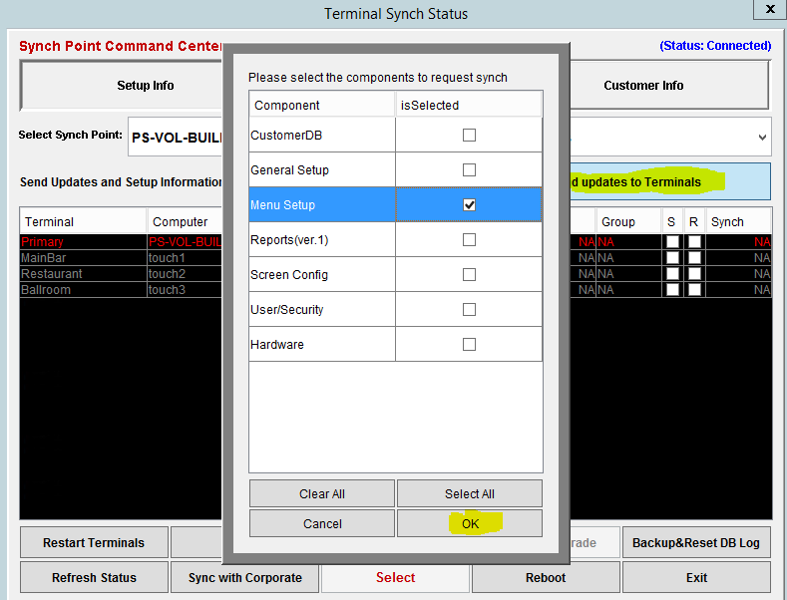

The Price Level will be associated with the terminals as part of Stage 2

